Introduction to Model Studio in Viya for Learners

COMMSDATA
ID variable
Name | Label | Description
Customer_ID | Primary Key | Unique identification of the customer.
Target variables
Name | Label | Description
Churn | Churn | Indicates whether customers churned.
Upsell_xsell | Xsell Upsell Flag | Indicates customer’s flag for cross-sell or up-sell.  (You do not use this variable in this course.)
Categorical-valued inputs
Name | Label | Description
credit_class | Credit Class | Credit category for an account or customer. It summarizes the overall credit worthiness of a customer or account.
sales_channel | Acquisition Channel | The way in which the consumer was persuaded to purchase company's services.
region | Account Region | Customer account region.
state | Account State | Customer state location.
city | Account City | City designation for customer address.
zipcode_primary | Account Code | Primary customer ZIP code.
product_plan_desc | Plan Name | Customer’s product plan.
handset_age_grp | Handset Age Group | Customer’s handset age in days.
handset | Handset Mfg | Handset manufacturer. Values include Apple, HTC, LG, Motorola, Nokia, Samsung, and Unknown.
lifestage | Plan Life Stage | Type of contract.
rp_pooled_ind | Pooled Rate Plan | Indicates whether customer has pooled rate.
call_center | Last Call Center Used | Location of the last call center used.
issue_level1 | Call Center Issue Level 1 | Level 1 reason of the call.
issue_level2 | Call Center Issue Level 2 | Level 2 reason of the call.
call_category_1 | Call Center Category 1 | Category 1 for the call.
call_category_2 | Call Center Category 2 | Category 2 for the call.
resolution | Final Resolution | Resolution action taken by call center.
verbatims | Survey Verbatim | Feedback from customers via call centers.
Interval-valued inputs
Name | Label | Description
lifetime_value | Lifetime Value | Customer’s value.
avg_arpu_3m | 3M Avg Revenue per User | Average revenue for the past three months.
acct_age | Account Tenure | Number of months that the account has been active.
billing_cycle | Billing Cycle | Customer’s billing cycle (period of the month).
nbr_contract_ltd | Total Number Contract lifetime | Number of contracts during life cycle.
rfm_score | Account Ranking (RFM Score) | Customer’s account score.
Est_HH_Income | Estimated HH Income | Household income.
region_lat | Account Region Latitude | Customer region latitude.
region_long | Account Region Longitude | Customer region longitude.
state_lat | Account State Latitude | State latitude.
state_long | Account State Longitude | State longitude.
city_lat | Account City Latitude | Customer city latitude.
city_long | Account City Longitude | Customer city longitude.
zip_lat | Account ZIP Code Latitude | ZIP code latitude.
zip_long | Account ZIP Code Longitude | ZIP code longitude.
cs_med_home_value | Census Area Median Home Value Index | Median home value in customer’s area.
cs_pct_home_owner | Census Area Percent Home Owner | Percentage home owner in customer’s area.
cs_ttl_pop | Census Area Total Population | Population in customer’s area.
cs_hispanic | Census Area Hispanic | Hispanic population in customer’s area.
cs_caucasian | Census Area Caucasian | Caucasian population in customer’s area.
cs_afr_amer | Census Area  African-American | African-American population in customer’s area.
cs_other | Census Area Other | Other population in customer’s area.
cs_ttl_urban | Census Area Total Urban | Urban population in customer’s area.
cs_ttl_rural | Census Area Total Rural | Rural population in customer’s area.
cs_ttl_male | Census Area Total Males | Male population in customer’s area.
cs_ttl_female | Census Area Total Females | Female population in customer’s area.
cs_ttl_hhlds | Census Area Total Households | Households in customer’s area.
cs_ttl_mdage | Census Area Median Age | Median age in customer’s area.
mb_inclplan | Plan Data MB | MB included in the plan.
ever_days_over_plan | Total Days Over Plan | Total days over the plan.
ever_times_over_plan | Total Times Over Plan | Total times over the plan.
data_device_age | Avg Age of Devices on Plan | Average age of devices on the plan.
equip_age | Handset Age | Age of equipment history, whether mobile device, smartphone, or another handset type.
mfg_apple | Own Apple | Apple manufactured device. 1 is Yes, 0 means No.
mfg_samsung | Own Samsung | Samsung manufactured device. 1 is Yes, 0 means No.
mfg_htc | Own HTC | HTC manufactured device. 1 is Yes, 0 means No.
mfg_motorola | Own Motorola | Motorola manufactured device. 1 is Yes, 0 means No.
mfg_lg | Own LG | LG manufactured device. 1 is Yes, 0 means No.
mfg_nokia | Own Nokia | Nokia manufactured device. 1 is Yes, 0 means No.
delinq_indicator | Delinquent Indicator | Delinquency indicator. Scale varies from -2 to +4, depending on customer history.
times_delinq | Consecutive Mths Delinquent | Consecutive months in default.
count_of_suspensions_6m | Times Suspended Last 6M | Times suspended in the past six months.
avg_days_susp | Days Suspended Last 6M | Days suspended in the past six months.
calls_total | Total Calls Curr | Current number of calls.
calls_in_pk | Calls Incoming Peak | Number of calls received in peak time.
calls_in_offpk | Calls Incoming Off-Peak | Number of call received off peak time.
calls_out_offpk | Calls Outgoing Off-Peak | Number of calls made in peak time.
calls_out_pk | Calls Outgoing Peak | Number of calls made off peak time.
mou_total_pct_MOM | Minutes Total Pct Change Month over Month | Percentage of minutes change month over month.
mou_onnet_pct_MOM | Minutes on Network Pct Change Month over Month | Percentage of minutes on network change month over month.
mou_roam_pct_MOM | Minutes Roaming Pct Change Month over Month | Percentage of minutes on roaming change month over month.
mou_onnet_6m_normal | 6M Avg Minutes on Network Normally Distributed | Minutes of use on network over six months normally distributed.
mou_roam_6m_normal | 6M Avg Minutes Roaming Normally Distributed | Minutes of use in roaming over six months normally distributed.
voice_total_bill_mou_curr | Total Voice Billed Minutes of Use | Current minutes of voice billed.
tot_voice_chrgs_curr | Total Voice Charges | Current minutes of voice charged.
tot_drpd_pr1 | Number of Dropped Calls 1 Mth Prior | Number of dropped calls on the previous month.
bill_data_usg_m03 | 3M Avg Billed Data Usage | Average data billed over the past three months.
bill_data_usg_m06 | 6M Avg Billed Data Usage | Average data billed over the past six months.
bill_data_usg_m09 | 9M Avg Billed Data Usage | Average data billed over the past nine months.
mb_data_usg_m01 | MB Data Usage 1 Mth Prior | MB data used on the previous month.
mb_data_usg_m02 | MB Data Usage 2 Mths Prior | MB data used prior two months.
mb_data_usg_m03 | MB Data Usage 3 Mths Prior | MB data used prior three months.
mb_data_ndist_mo6m | 6M Avg Billed Data Usage Normally Distributed | Data used on network over six months normally distributed.
mb_data_usg_roamm01 | MB Data Usage Roam 1 Mth Prior | Data used in roaming in the previous month.
mb_data_usg_ roamm02 | MB Data Usage Roam 2 Mths Prior | Data used in roaming prior two months.
mb_data_usg_ roamm03 | MB Data Usage Roam 3 Mths Prior | Data used in roaming prior three months.
data_usage_amt | Data Usage Amount | Total data usage amount over last month.
tweedie_adjusted | Data Usage Amt Tweedie Distributed | Data used in Twitter.
tot_mb_data_curr | Total MB of Data Usage | Current MB data used.
tot_mb_data_roam_curr | Total MB of Roam Data Usage | Current MB data used in roaming.
bill_data_usg_total | Total Billed Data usage | Total billed data.
tot_overage_chgs | Total Overage Charges | Total overage charged.
data_prem_chrgs_curr | Premium Data Charges | Premium data charged.
nbr_data_cdrs | Number of Data Records | Number of call detail records.
avg_data_chrgs_3m | 3M Avg Data Charges | Average data charged in the past three months.
avg_data_prem_chrgs_3m | 3M Avg Premium Data Charges | Average premium data charged in the past three months.
avg_overage_chrgs_3m | 3M Avg Overage Charges | Average overage data charged in the past three months.
nbr_contacts | Number Times Customer Contacted | Number of contacts customer made to the company.
calls_TS_acct | Number Calls Tech Support | Number of tech support calls.
open_tsupcomplnts | Open Tech Support Complaints | Number of tech support complains opened.
num_tsupcomplnts | Tech Support Complaints - LTD | Number of tech support complains.
unsolv_tsupcomplnts | Unresolved Tech Support Complaints - LTD | Number of unsolved tech support complaints.
wrk_orders | Open Work Orders | Number of open work.
days_openwrkorders | Days of Open Work Orders | Days of open work.
resolved_complnts | Resolved Complaints | Number of complaints resolved.
calls_care_acct | Number Calls Care Center | Call center care account assignment, which takes values between 0-9.
calls_care_3mavg_acct | Number Calls Care Center 3 Month Avg | Call center care account score over past three months averaged.
calls_care_6mavg_acct | Number Calls Care Center 6 Month Avg | Call center care account score over past six months averaged.
res_calls_3mavg_acct | Resolved Calls – 3Mo Average | Average number of resolved customer service calls over past three months for the customer account.
res_calls_6mavg_acct | Resolved Calls – 6Mo Average | Average number of resolved customer service calls over past six months for the customer account.
last_rep_sat_score | Last Call Satisfaction Rating Given | Latest customer service representative satisfaction score (given by past customers).
network_mention | Network Issues Discussed | Number of network issues discussed.
service_mention | Service Issues Discussed | Number of service issues discussed.
price_mention | Price Issues Discussed | Number of prices issues discussed.
times_susp | Number of Times Suspended | Number of times suspended.
curr_days_susp | Number of Days Suspended | Number of days suspended.
pymts_late_ltd | Total Late Payments Lifetime | Number of late payments.
calls_care_ltd | Total Calls to Care Lifetime | Number of calls to call center.
MB_Data_Usg_M04 | MB of Data Usage  Month 4 | MB data used in past four months.
MB_Data_Usg_M05 | MB of Data Usage  Month 5 | MB data used in past five months.
MB_Data_Usg_M06 | MB of Data Usage  Month 6 | MB data used in past six months.
MB_Data_Usg_M07 | MB of Data Usage  Month 7 | MB data used in past seven months.
MB_Data_Usg_M08 | MB of Data Usage  Month 8 | MB data used in past eight months.
MB_Data_Usg_M09 | MB of Data Usage  Month 9 | MB data used in past nine months.
seconds_of_data_norm | Seconds of Data - Normalized | Number of seconds of data normalized.
seconds_of_data_log | Seconds of Data - Natural Log | Number of seconds of data transformed by log.

Open Viya for Learners and Create a New Model Studio Project:
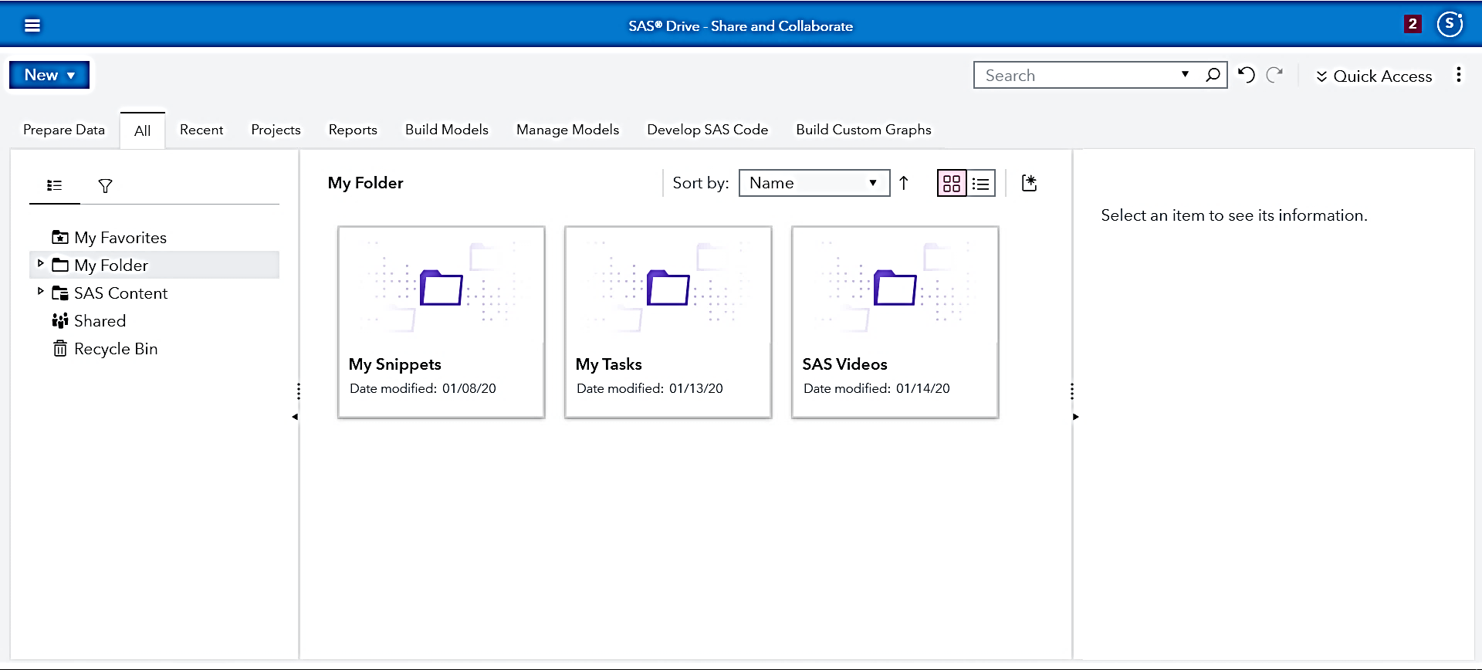

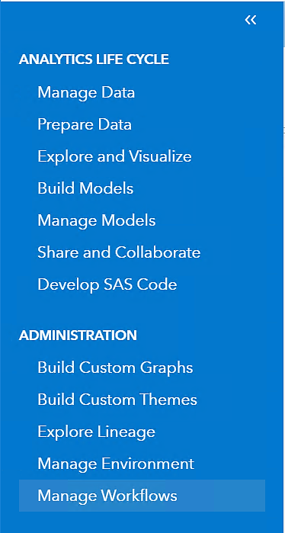

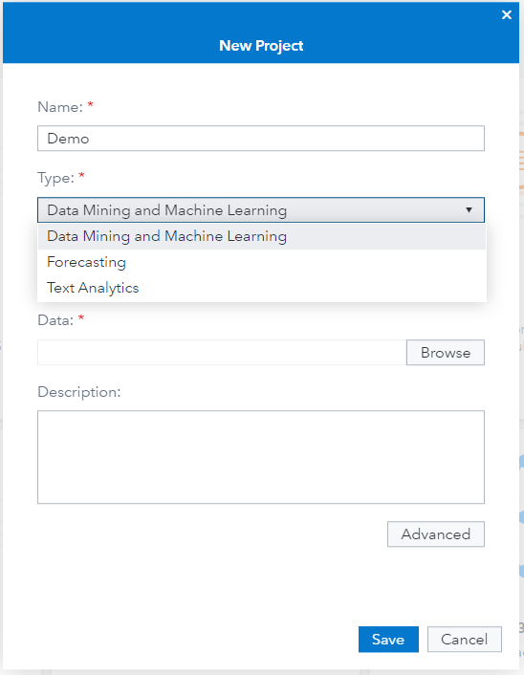
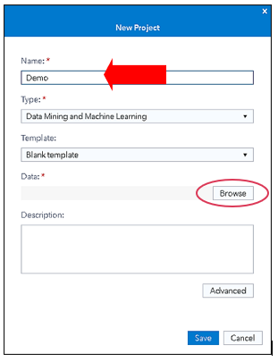

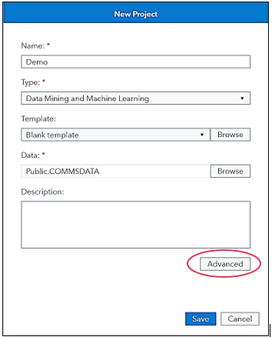

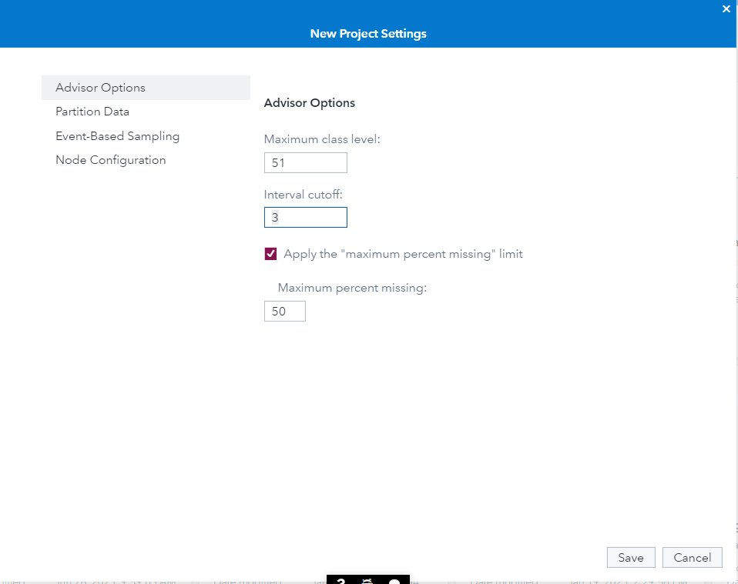
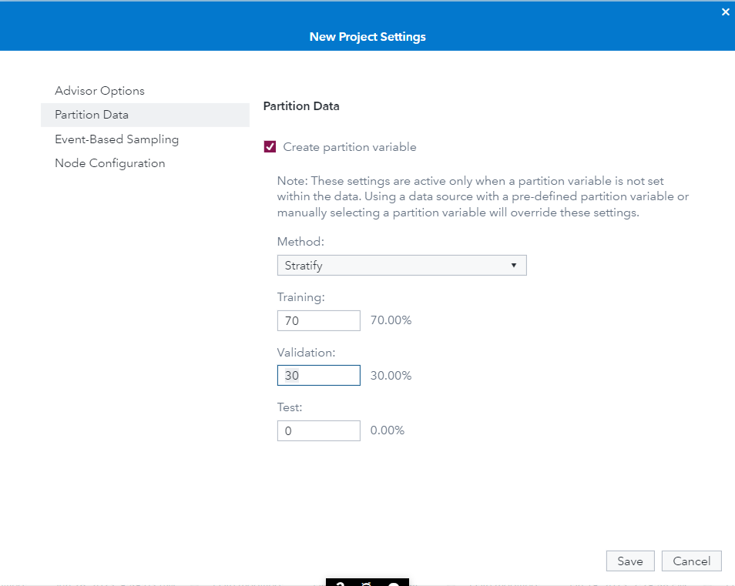
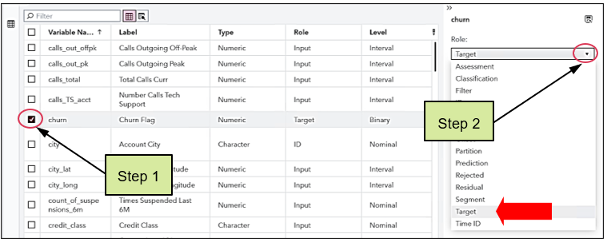

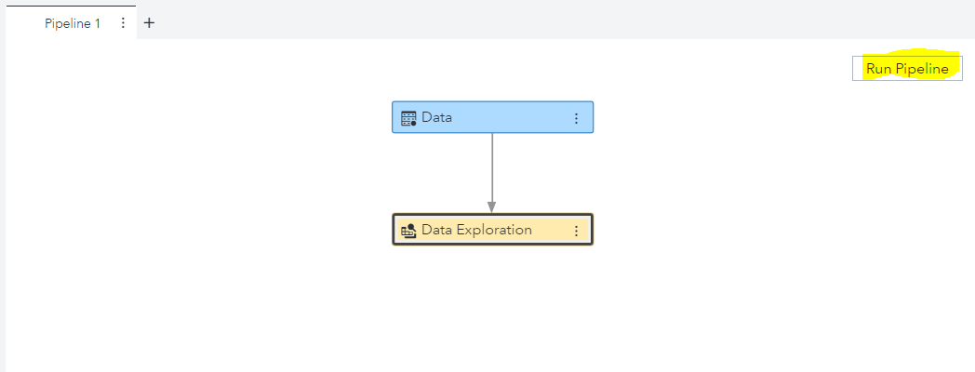

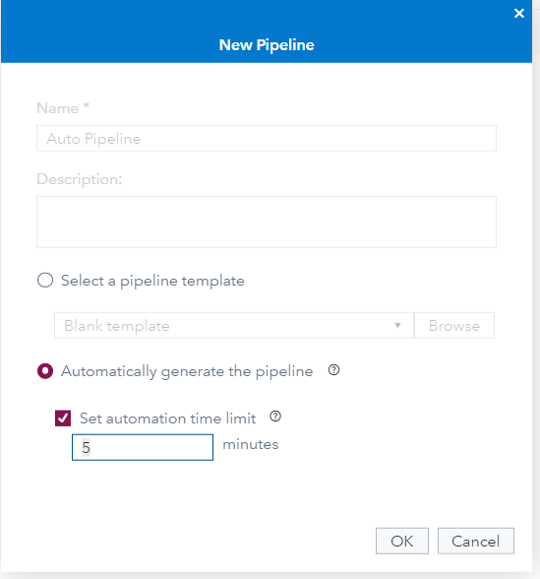

Machine Learning Models:
Ensembles of Trees:

Neural Networks:
Support Vector Machines

Model Performance:

